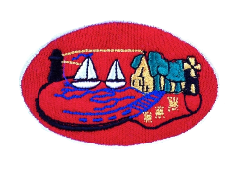
12th September 2022
Dear Parents/Carers
After School Clubs will resume from Tuesday 20th September.
From now until 27th October clubs on offer will be:
 | 2-3pm  (P2 & P3) | 3-4pm  (P4 to P7)
Monday | Mindfulness | Football with Mr Rooney
Tuesday | Little Tiger Cubs- Get into Martial Arts | Little Tiger Cubs- Get into Martial Arts
Wednesday | Cookery | Cookery
Thursday | Games | Transfer Club

The cost for each session will be £3.00.
Sessions are to be booked beforehand and all money is to be paid in advance.
This will be for a trial period to be reviewed by the Board of Governors before the Christmas term.
Booking forms are attached for the next 6 weeks to be returned on the Monday morning.
Should you have any difficulties or require further assistance please feel free to contact the school office.
Yours sincerely

F.Macfarlane

