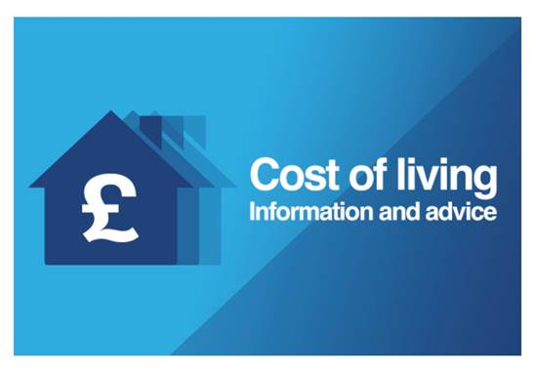

NI Direct has useful information for families and children to help with the cost of living. There is information with regards to help with energy costs, help with income and help for families and children. See below for the relevant web-links:

https://www.nidirect.gov.uk/campaigns/cost-living

Help with energy costs
- Help with domestic energy costs
- Energy saving grants
- Winter Fuel Payment
- Advice if you're struggling to pay your energy bills
- Staying warm in winter
- Cold Weather Payment

Help with your income
- Cost of Living Payments
- Unclaimed benefits? Make the call
- Who can claim Universal Credit
- Benefits Calculator
- Income, benefits and Pension Credit
- Extra help starting or staying in work
- Adviser Discretion Fund (ADF)
- Redundancy and benefits
- Employment support for people with disabilities or health conditions

Help for families and children
- Financial support for parents and children
- Child maintenance
- Help paying for approved childcare
- Universal Credit payments for children and childcare
- Social Fund Sure Start Maternity Grant
- Support for parents with disabilities
- Home to school transport
- Free milk, fruit, vegetables and vitamins
- School uniform and uniform grants

