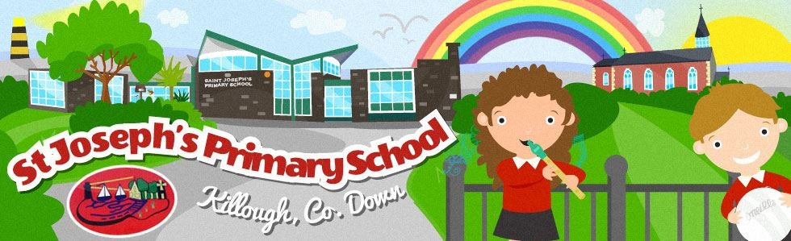

Holidays List 2024-2025

**School begins for all pupils**

Wednesday 28th August 2024

Wednesday 28th August, Thursday 29th August and Friday 30th August school will close at 12pm as there are no school meals available.

Monday 2nd September, normal school hours will resume.

(P1 finish at midday until Friday 27th September, full day from Monday 30th September 2024)

**Autumn Half Term**

**School finishes on Friday 25th October**

Monday 28th October to Friday 1st November 2024 inclusive.

School reopens Monday 4th November 2024.

**Christmas Holidays**

**School finishes on Friday 20th December at 11:00am**

Monday 23rd December 2024 to Friday 3rd January 2025 inclusive.

School reopens Monday 6th January 2025.

**Spring Half Term**

**School finishes on Friday 7th February at 11:00am**

Monday 10th February to Friday 14th February 2025 inclusive.

**St Patrick’s Day**

Monday 17th March 2025.

**Easter Holidays**

**School finishes on Thursday 17th April at 11:00**

Friday 18th April to Friday 25th April 2025 inclusive

School reopens Monday 28th April 2025.

**May Bank Holidays**

Monday 5th May 2025.

**School finishes on Friday 23rd May at 11:00am**

Monday 26th May 2025 to Friday 30th May 2025 inclusive.

School reopens Monday 2nd June 2025.

**School finishes on Friday 27th June 2025 @ 11:00am**

There will be NO dinners on this day.

**Holidays should not be booked during term time**

**Dates above may be changed at short notice to facilitate staff training**